

 

**Java Assignment 5: Processing**[**Daniel Shiffman, King of Processing**](https://www.youtube.com/channel/UCvjgXvBlbQiydffZU7m1_aw)

**Ver 1.0 Last Updated: 7/16/2025 9:20 AM**

Please create the following sketches inside Processing.  
DO NOT SAVE ON THE C DRIVE, MAKE A FOLDER ON YOUR GOOGLE DRIVE CALLED processing sketches

1. **Sketch 1: Already Done!  
   Make this sketch**

void setup() { //one way of doing it

  size(800, 800);

}

void draw() {

  background(255);

  strokeWeight(5);

  stroke(0);

  line(100, 200, 300, 100);

  stroke(255, 0, 0);

  fill(0, 255, 0);

  rect(400, 200, 50, 150);

  stroke(0, 0, 255);

  noFill();

  ellipse(mouseX, mouseY, 30, 30);

}

1. **Sketch 2: Redbricks  
   Make this sketch in a sketch called redbricks(size 800,800)  
   **
2. **Sketch 3: Triangles  
   Make this sketch in a sketch called triangles(size 800,800)  
   **
3. **Sketch: LineBlaster(size 800,800)  
   Don’t need a mouse method, only setup and draw  
   Use the mouseX and mouseY as the 3rd and 4th arguments to the line method.  
   Your while loop should be while(count <= width)  
   **
4. **BlockOfCircles(size 800,800)**
5. **Loopy(size 800,800)  
   while loop uses while(temp < width) and goes up by 150**
6. **MousePressed(size 800, 800)  
   Inside draw, use if(mousePressed)**
7. **Cake (see setup code)  
   Pick a language (I chose Italian). Convert the circle clicker Array program that we did in class (the starter code is further down this page) so that it counts from 1 to 10 in your chosen language. I chose to leave the circles in the code, but that is not necessary. It should properly wrap around to one when your array gets too big (over the size of 10). (you should be using a String array to store the names of** **each number)**  
   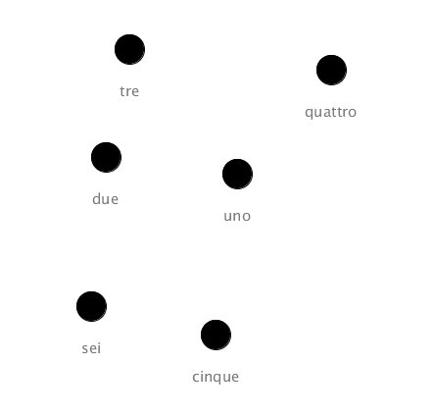

**When they click through and reach the end, have the number system change to a different language. So after it counts to ten in italian, have it then starting to count to ten in korean. After korean is done, have it go to ten in english. When english is done, have it loop back to italian.**

|  |
| --- |
| float[] xpos;  float[] ypos;  int count;  final int maxListSize = 20;  void setup(){    size(600, 600);    xpos = new float[maxListSize];    ypos = new float[maxListSize];    count = 0;  }  void draw(){    background(255);      for(int i = 0; i < xpos.length; i++){      fill(0);      ellipse(xpos[i], ypos[i], 20, 20);    }  }  void mousePressed(){    if (count >= xpos.length){      count = 0;    }    xpos[count] = mouseX;    ypos[count] = mouseY;    count++;  } |



|  |  |
| --- | --- |
| Project Name | Not really how processing works You make individual sketches |
| Sketch 2 Name | Redbricks |
| Sketch 3 Name | Triangles |
| Sketch 4 Name | LineBlaster |
| Sketch 5 Name | BlockOfCircles |
| Sketch 6 Name | Loopy |
| Sketch 7 Name | MousePressed |
| Sketch 8 Name | Cake |

|  |  |
| --- | --- |
| Rubric | |
| **Redbricks** | **10** |
| **Triangles** | **10** |
| **LineBlaster** | **15** |
| **BlockOfCircles** | **15** |
| **Loopy** | **20** |
| **MousePressed** | **25** |
| **Cake** | **40** |
| **TOTAL** | **135** |